FACULTY EVALUATION
Programme Name: SEP Scale Alumni Masterclass Module 1 Tanzania (11th May 2026 - 15th May 2026)
Session: Reflect on Vision and Mission || Reflect on charism || Identify alignment to social enterprise
Faculty Name: Dr. Joan Wanjiku Ndung'u - Gitahi
No. of Respondents: 18
No. of Participants: 18
Evaluation Parameter | (%) Individual Score | (%) Programme Average
Punctuality (Commencement and Completion of Sessions) | 91 | 92
How well do you understand the core concepts presented? | 85 | 88
Rate your confidence in applying the new skills learnt | 86 | 85
Degree of Faculty preparedness for the sessions | 89 | 90
Content and methodology of the program | 88 | 90
Quality of class and group discussions | 89 | 89
The information presented in the course is relevant to my work (ministry) | 88 | 92
Average scores | 88 | 89

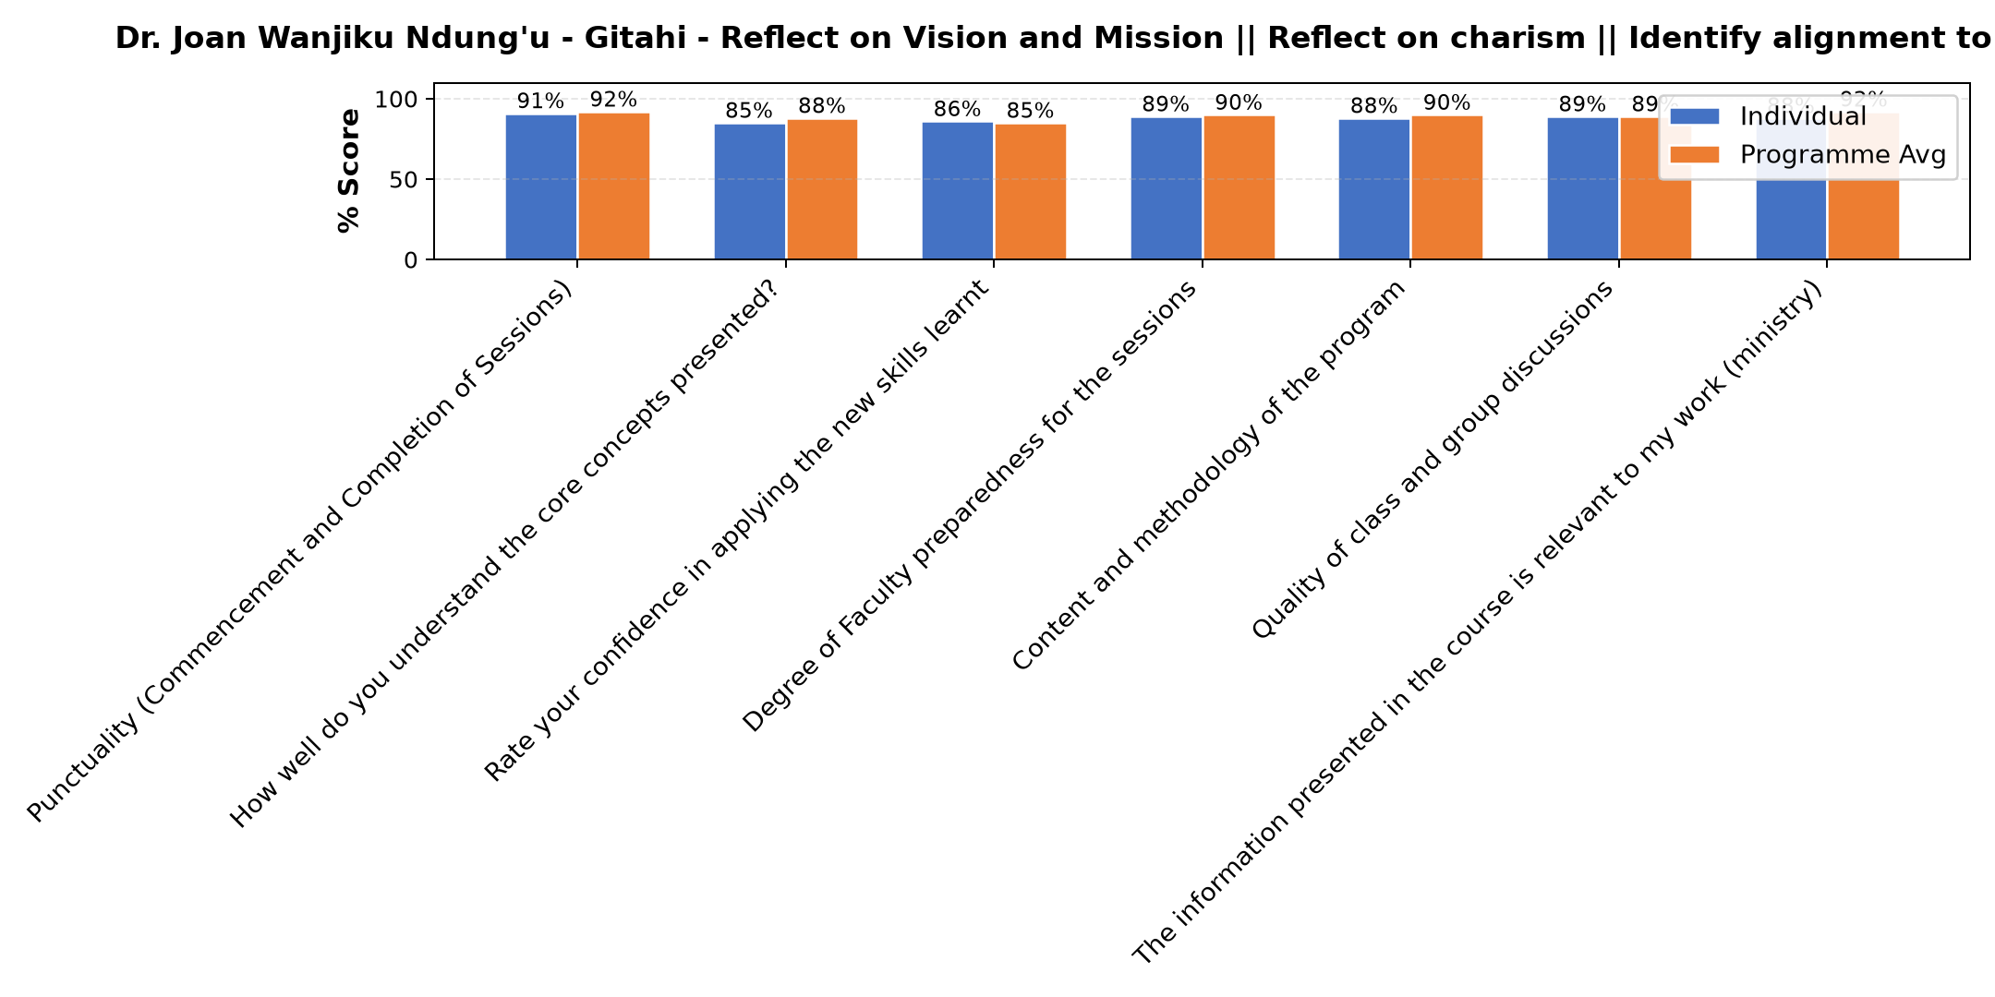

Comments & Feedback
- • Network
- • I have understood well the subject, and the period was so nice
- • Lack of clear goals, insufficient of funs or resources and negative attitudes among members.
- • Some times a network is not good.
- • Learning conditions
- • Transport to visit in all areas
- • May be time and space
- • The major barrier preventing me from applying t the knowledge I gained today is making people understand the reality that even if we operate guided by the spirituality, charism, mission, vision and values, yet we need to move with the fast moving and expensive world of science and technology. Some parents may demand me to be more compassionate and take advantage of not paying school fees knowing that we operate as religious.
- • Only network
- • Network problem
- • Poor planning
- • Welll organized
- • Barriers that may prevent me from applying what I have learned include lack of time due to many responsibilities, resistance to change and preference for familiar methods, fear of making mistakes or lack of confidence, and limited support from colleagues or the work environment. Other challenges include lack of necessary resources or tools to implement the new knowledge, information overload that makes it difficult to remember everything, and training that is not directly related to daily tasks or is not reinforced through continuous practice and follow-up.
- • The major barrier is making the administration of our SE to understand and to give room for the things I need to change from how we have been doing to what I have learnt today.
- • Time
SUBMITTED THROUGH:
SBS Evaluation Automation System

